Bash Script Tasks
- Create a bash script to check if a directory is available or not.
Step 1:- Create a bash file with touch or vi command
Step 2:- Use shebang character and shell path to be used for kernel
Step 3:- Take one input from the user for the directory path and store it in a variable
Step 4:- Check whether the directory exists or not using the if condition with the -d option
Step 5:- If the directory exists, print the message “Directory is available”
Step 6:- Otherwise, in the else part, print the message “Directory is not available”
Step 7:- To end the if condition we use the fi keyword
Step 8:- This way we can check whether any directory is available at a custom path
Step 9:- Finally, run this file with the bash command
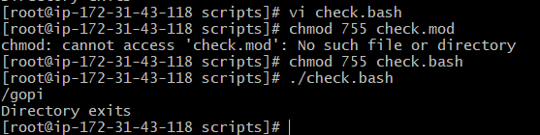

- Create a bash script to create multiple files.
Step 1:- Create a bash file with touch or vi command
Step 2:- Use shebang character and shell path to be used for kernel
Step 3:- Take three inputs from the user: first for the folder path, second for the number of files we want to create, and third for the file name
Step 4:- First we take the folder path where we want to save the files, then check whether the folder exists or not using the if condition with the -d option
Step 5:- Then take the numerical input and use it to create a for loop for creating the files
Step 6:- Inside the for loop, use the touch command with the file name and loop number to create each file
Step 7:- To end the if condition we use the fi keyword, and to end the for loop we use the done keyword
Step 8:- This way we can create many files at custom folder paths
Step 9:- Finally, run this file with the bash command
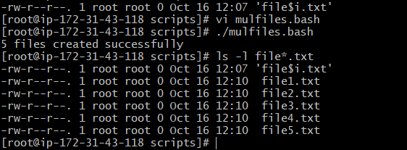

- Create a bash script to take a backup of a directory.
Step 1:- Create a bash file with touch or vi command
Step 2:- Use shebang character and shell path to be used for kernel
Step 3:- Take two inputs from the user: first for the source directory path we want to back up, and second for the backup destination folder path
Step 4:- Check whether the source directory exists or not using the if condition with the -d option
Step 5:- Check whether the backup destination folder exists, and if it does not, create it using the mkdir command
Step 6:- Store the current date and time in a variable so that each backup gets a unique name
Step 7:- Use the tar command to compress the source directory into a backup file (.tar.gz) with the date and time in its name, and save it in the destination folder
Step 8:- Print a message to show whether the backup was successful or not
Step 9:- To end the if condition we use the fi keyword
Step 10:- This way we can take a backup of any directory at a custom folder path
Step 11:- Finally, run this file with the bash command
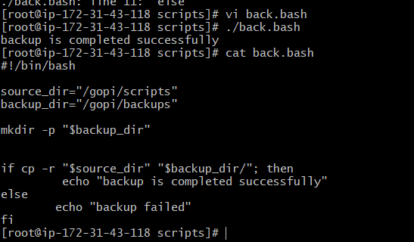

- Create a bash script to install Nginx on an EC2 server.
Step 1:- Create a bash file with touch or vi command
Step 2:- Use shebang character and shell path to be used for kernel
Step 3:- Update the package list of the server using the package manager (apt update for Ubuntu, yum update for Amazon Linux)
Step 4:- Check whether Nginx is already installed or not using the if condition with the command -v option
Step 5:- If Nginx is not installed, install it using the package manager with the -y option so that it does not ask for confirmation
Step 6:- Start the Nginx service using the systemctl start command
Step 7:- Enable the Nginx service using the systemctl enable command so that it starts automatically after a server reboot
Step 8:- Check the status of the Nginx service and print a message to show whether the installation was successful or not
Step 9:- To end the if condition we use the fi keyword
Step 10:- Allow HTTP port 80 in the EC2 Security Group so that Nginx can be accessed from the browser
Step 11:- Finally, run this file with the bash command using sudo, and open the server's public IP in the browser to see the Nginx welcome page

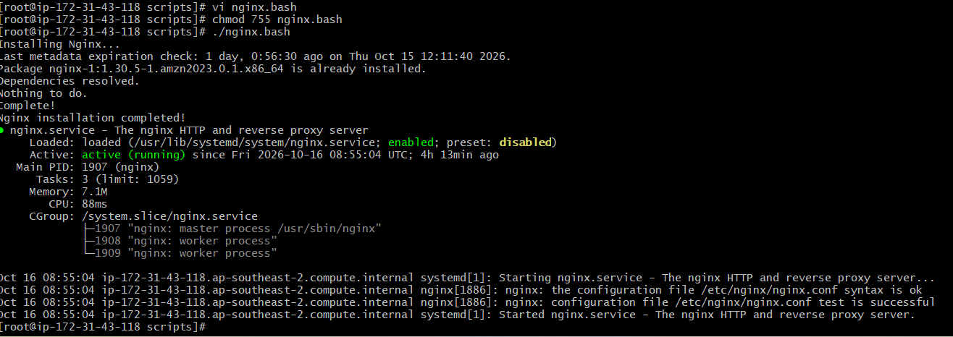

- Create a bash script to install Apache Tomcat on an EC2 server.
Step 1:- Create a bash file with touch or vi command
Step 2:- Use shebang character and shell path to be used for kernel
Step 3:- Update the package list of the server using the package manager (apt update for Ubuntu, yum update for Amazon Linux)
Step 4:- Install Java (JDK) using the package manager with the -y option, because Tomcat needs Java to run
Step 5:- Check whether Java is installed or not using the java -version command
Step 6:- Create a directory (for example /opt/tomcat) where Tomcat will be installed, using the mkdir command
Step 7:- Download the Tomcat tar.gz package from the official Apache website using the wget command
Step 8:- Extract the downloaded package into the /opt/tomcat directory using the tar command
Step 9:- Give execute permission to the startup scripts present in the Tomcat bin folder using the chmod command
Step 10:- Start the Tomcat server using the startup.sh script
Step 11:- Check whether Tomcat is running and print a message to show whether the installation was successful or not
Step 12:- To end the if condition we use the fi keyword
Step 13:- Allow port 8080 in the EC2 Security Group so that Tomcat can be accessed from the browser
Step 14:- Finally, run this file with the bash command using sudo, and open the server’s public IP with port 8080 in the browser to see the Tomcat home page

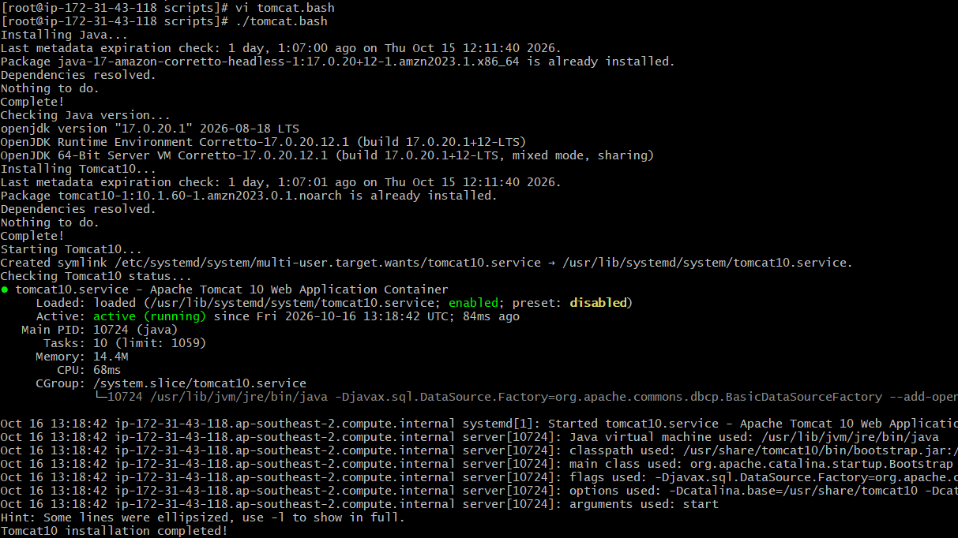

- Create a bash script to check if the Nginx service is running, if not running then script should start the service.
Step 1:- Create a bash file with touch or vi command
Step 2:- Use shebang character and shell path to be used for kernel
Step 3:- Store the service name (nginx) in a variable so that it can be reused in the script
Step 4:- Check whether the Nginx service is running or not using the if condition with the systemctl is-active command
Step 5:- If the service is running, print the message “Nginx is running”
Step 6:- Otherwise, in the else part, print the message “Nginx is not running, starting the service”
Step 7:- Start the Nginx service using the systemctl start command
Step 8:- Check the status again after starting, and print a message to show whether the service started successfully or not
Step 9:- To end the if condition we use the fi keyword
Step 10:- This way we can make sure the Nginx service is always running on the server
Step 11:- Finally, run this file with the bash command using sudo
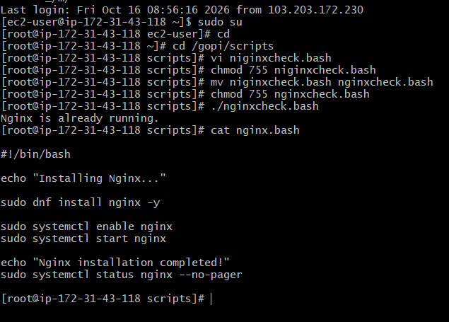

- Create a bash script for a calculator.
Step 1:- Create a bash file with touch or vi command
Step 2:- Use shebang character and shell path to be used for kernel
Step 3:- Take two numbers as input from the user and store them in variables
Step 4:- Show a menu of operations to the user: addition, subtraction, multiplication, and division
Step 5:- Take the user’s choice as input and store it in a variable
Step 6:- Use a case statement to check the choice and perform the matching operation using arithmetic expansion
Step 7:- For division, check that the second number is not zero using the if condition, and print an error message if it is zero
Step 8:- Print the result of the selected operation
Step 9:- To end the if condition we use the fi keyword, and to end the case statement we use the esac keyword
Step 10:- This way we can perform basic calculations from the terminal
Step 11:- Finally, run this file with the bash command
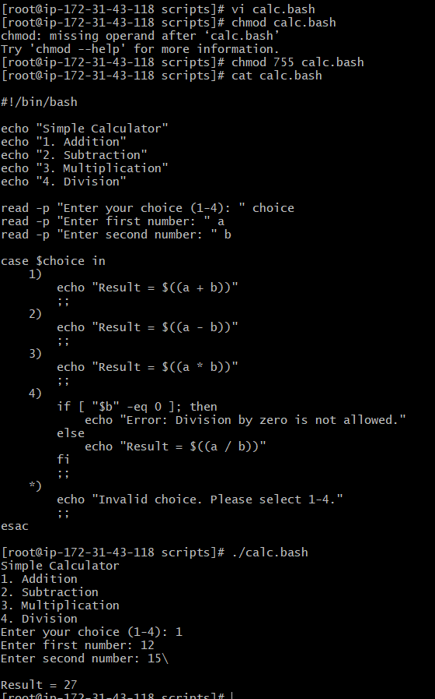

- Create a bash script to check if a directory exists, if not then create a directory.
Step 1:- Create a bash file with touch or vi command
Step 2:- Use shebang character and shell path to be used for kernel
Step 3:- Take one input from the user for the directory path and store it in a variable
Step 4:- Check whether the directory exists or not using the if condition with the -d option
Step 5:- If the directory exists, print the message “Directory already exists”
Step 6:- Otherwise, in the else part, create the directory using the mkdir command
Step 7:- Check whether the directory was created successfully and print the message “Directory created”
Step 8:- To end the if condition we use the fi keyword
Step 9:- This way we can make sure a directory is always available at a custom path
Step 10:- Finally, run this file with the bash command
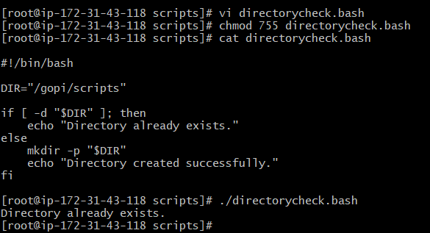

- Create a bash script to delete the last 3 lines of a file.
Step 1:- Create a bash file with touch or vi command
Step 2:- Use shebang character and shell path to be used for kernel
Step 3:- Take one input from the user for the file name (or file path) and store it in a variable
Step 4:- Check whether the file exists or not using the if condition with the -f option
Step 5:- If the file exists, count the total number of lines in the file using the wc -l command and store it in a variable
Step 6:- Calculate the number of lines to keep by subtracting 3 from the total number of lines
Step 7:- Use the head command with the -n option to keep only the first lines, and save the output in a temporary file
Step 8:- Replace the original file with the temporary file using the mv command
Step 9:- Print the message “Last 3 lines deleted” to show the operation is completed
Step 10:- Otherwise, in the else part, print the message “File does not exist”
Step 11:- To end the if condition we use the fi keyword
Step 12:- Finally, run this file with the bash command

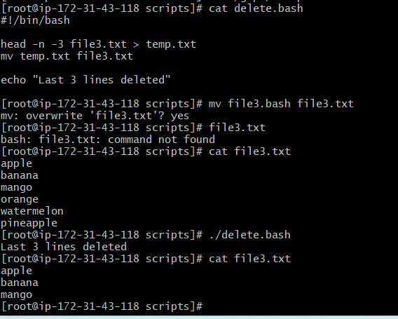
- Bash script to monitor cpu and if it is more than 80% then send email notification.
Step 1:- Create a bash file with touch or vi command
Step 2:- Use shebang character and shell path to be used for kernel
Step 3:- Store the CPU threshold value (80) and the receiver’s email address in variables
Step 4:- Get the current CPU usage using the top command (or mpstat/vmstat), filter the idle value with the awk command, and subtract it from 100 to get the used CPU percentage
Step 5:- Store the CPU usage value in a variable and convert it to a whole number so that it can be compared
Step 6:- Check whether the CPU usage is greater than the threshold using the if condition with the -gt option
Step 7:- If the CPU usage is more than 80%, send an email notification to the receiver using the mail command, with a subject and a message that includes the current CPU usage
Step 8:- Otherwise, in the else part, print the message “CPU usage is normal”
Step 9:- To end the if condition we use the fi keyword
Step 10:- Install and configure a mail service (such as mailutils or ssmtp) on the EC2 server so that emails can be sent
Step 11:- To monitor the CPU continuously, schedule the script with cron so that it runs automatically at a fixed interval (for example every 5 minutes)
Step 12:- Finally, run this file with the bash command
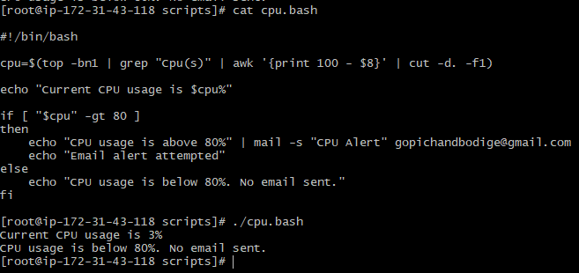

- Bash script to monitor disk space and if it is more than 80% then send email notification.
Step 1:- Create a bash file with touch or vi command
Step 2:- Use shebang character and shell path to be used for kernel
Step 3:- Store the disk usage threshold value (80) and the receiver’s email address in variables
Step 4:- Get the current disk usage of the root partition using the df -h command, filter the usage percentage column with the awk command, and remove the % symbol using the sed or cut command
Step 5:- Store the disk usage value in a variable so that it can be compared
Step 6:- Check whether the disk usage is greater than the threshold using the if condition with the -gt option
Step 7:- If the disk usage is more than 80%, send an email notification to the receiver using the mail command, with a subject and a message that includes the current disk usage
Step 8:- Otherwise, in the else part, print the message “Disk usage is normal”
Step 9:- To end the if condition we use the fi keyword
Step 10:- Install and configure a mail service (such as mailutils or ssmtp) on the EC2 server so that emails can be sent
Step 11:- To monitor the disk space continuously, schedule the script with cron so that it runs automatically at a fixed interval (for example every hour)
Step 12:- Finally, run this file with the bash command
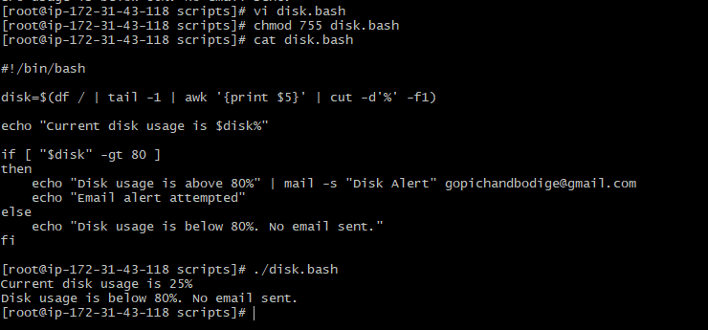

- Bash script to monitor memory and if it is more than 80% then send email notification.
Step 1:- Create a bash file with touch or vi command
Step 2:- Use shebang character and shell path to be used for kernel
Step 3:- Store the memory threshold value (80) and the receiver’s email address in variables
Step 4:- Get the total memory and the used memory using the free command, and filter the values with the awk command
Step 5:- Calculate the memory usage percentage by dividing the used memory by the total memory and multiplying by 100, and store it in a variable as a whole number so that it can be compared
Step 6:- Check whether the memory usage is greater than the threshold using the if condition with the -gt option
Step 7:- If the memory usage is more than 80%, send an email notification to the receiver using the mail command, with a subject and a message that includes the current memory usage
Step 8:- Otherwise, in the else part, print the message “Memory usage is normal”
Step 9:- To end the if condition we use the fi keyword
Step 10:- Install and configure a mail service (such as mailutils or ssmtp) on the EC2 server so that emails can be sent
Step 11:- To monitor the memory continuously, schedule the script with cron so that it runs automatically at a fixed interval (for example every 5 minutes)
Step 12:- Finally, run this file with the bash command

